

Report
Of
Topic
Edunet Foundation
AICTE data analytic internship
Submitted
To
School of Computer Science and Engineering
IILM University, Greater Noida, U.P.
In partial fulfilment of the requirement of degree of
B.Tech CSE
By
Roll Number of Student:25scs1003001266
Name of Student: ADITYA SINGH
Batch: 2cse37
2026-2027



CANDIDATE’S DECLARATION
I, Aditya singh do hereby declare that the internship report titled deloitte data analytics job
simulation has been completed by me to fulfil the requirement for the award of the degree of
Bachelor of Technology in CSE. All the references have been quoted and I have not taken as
such any material from any other source. I affirm to you that this report is my own and has
not been submitted to any other institute for any degree/diploma requirement and further I
shall be solely responsible for any kind of copyright violation in this regard.
Signature
Student Name: ADITYA SINGH
Roll No.25SCS1003001266



ACKNOWLEDGEMENT
I am using this opportunity to express my gratitude to everyone who supported me throughout
the Internship Program. I am thankful for their aspiring guidance, invaluably constructive
criticism and friendly advice during this work. I am sincerely grateful to them for sharing
their truthful and illuminating views on a number of issues related to this work.
I express my gratitude to my parents for their blessings.
Signature
Student Name: ADITYA SINGH
Roll No..25SCS1003001266

Chapter No. | Chapter Name | Page Nos.
 | Cover Page | ----
1. | Candidate’s Declaration
2. | Acknowledgment
3. | Internship Completion Certificate
4. | Project Description  4 .1 Introduction  4.2 Organization Profile  4.3 Problem Statement  4.4 Project Objectives  4.5 Scope of the Project  4.6 Technologies and Tools Used  4.7 System Architecture  4.8 Methodology  4.9 Expected Outcomes  4.10 Certificates of completion and other  communication mail proof must be attached
5. | Bibliography/References

PROJECT DESCRIPTION
4.1 Introduction
Data Analytics is an important field that involves collecting, processing, analyzing, and
interpreting data to identify meaningful patterns and support better decision-making. As
organizations increasingly generate large amounts of data, the ability to manipulate, analyze,
and visualize data has become an essential professional skill.
As part of the AICTE Internship offered by Edunet Foundation under the VOIS for
Tech Program, I am undergoing an internship in the field of Data Analytics. The internship
commenced on 10 August 2026 and is scheduled to continue until 10 September 2026. The
internship provides practical exposure to data analytics concepts, tools, techniques, data
visualization, and project-based learning.
During the internship, I am learning and applying data analytics techniques through practical
datasets and exercises. The planned activities include HR data analysis using Python,
agriculture data analysis, business and operations data analysis, dataset analysis and report
preparation with LLM assistance, and hands-on learning in data visualization.
The internship is currently ongoing, and therefore this report describes the work completed
and learning progress achieved so far, along with the planned project activities and expected
outcomes.
4.2 Organization Profile
Edunet Foundation is the organization providing the internship under the AICTE
Internship Program, leveraging the VOIS for Tech Program of Vodafone Idea
Foundation. The internship focuses on developing foundational and market-relevant
technical skills through an e-learning and project-based learning environment.
The VOIS for Tech platform provides learners with access to curated technical courses,
guidance from industry experts, masterclasses, and opportunities to work on practical
challenges. The internship also provides mentor guidance throughout the project
development process.
The internship structure includes weekly sessions covering different areas of Data Analytics.
The planned training progresses from introductory concepts to practical analysis of HR,
agriculture, business, and operations datasets, followed by project completion and
submission.

4.3 Problem Statement
Organizations generate data from various business activities, but raw data by itself does not
provide sufficient insight for effective decision-making. Data needs to be properly cleaned,
manipulated, analyzed, and visualized before meaningful conclusions can be obtained.
The primary problem addressed during this internship is to understand how raw datasets can
be transformed into useful information through data manipulation, analysis, and
visualization techniques.
The project-based activities aim to provide practical experience in analyzing datasets from
different domains such as HR, agriculture, business, and operations. The analysis involves
identifying relevant patterns, trends, relationships, and insights that can be communicated
through appropriate reports and visualizations.
4.4 Project Objectives
The major objectives of the internship project are:
1. To understand the fundamental concepts of Data Analytics.
2. To develop practical skills in data collection, processing, and manipulation.
3. To learn how to work with datasets using Python.
4. To understand techniques for cleaning and preparing datasets for analysis.
5. To perform exploratory analysis on different types of datasets.
6. To learn and apply data visualization techniques.
7. To represent analytical findings using suitable charts and graphical representations.
8. To analyze HR, agriculture, business, and operations-related datasets.
9. To use LLM assistance appropriately during dataset analysis and report preparation.
10. To develop the ability to convert raw data into meaningful insights.
11. To improve analytical thinking and problem-solving skills.
12. To complete a project based on the knowledge gained during the internship.
4.5 Scope of the Project
The scope of this internship project covers the fundamental and practical aspects of Data
Analytics. The project focuses primarily on understanding datasets, manipulating data,
performing analysis, and presenting findings through visualizations.
The internship activities include:
• Introduction to Data Analytics concepts, tools, and techniques.
• Understanding basic applications of AI and LLMs.
• HR data analysis using Python.

• Agriculture data analysis.
• Business and operations data analysis.
• Dataset analysis and report preparation.
• Learning and applying data visualization techniques.
• Project-based learning and discussion with mentors.
• Preparation and submission of the final project.
The internship schedule indicates that the project completion and submission activities are
planned toward the end of the internship period.
Since the internship is currently ongoing, the scope described in this report represents both
the activities already undertaken and the activities planned for completion during the
remaining internship period.
4.6 Technologies and Tools Used
The following technologies and tools are relevant to the internship activities described in the
internship plan:
1. Python
Python is being used for practical data analysis activities, including the planned HR data
analysis. It provides a flexible environment for manipulating and analyzing datasets.
2. Data Visualization Tools and Techniques
Data visualization is an important component of the internship. Visualization techniques are
being learned to represent analytical findings through charts and graphical formats.
3. VOIS for Tech LMS
The VOIS for Tech e-learning platform is used for accessing curated courses and completing
learning activities associated with the internship. The internship offer specifically mentions
access to the VOIS for Tech e-learning platform and completion of courses as part of the
internship.
4. Large Language Models (LLMs)
The internship includes an overview of AI and LLMs and also includes dataset analysis and
report preparation with LLM assistance.

5. Datasets
Different datasets are used for practical analysis, including HR, agriculture, business, and
operations-related datasets.
Note: The exact libraries, software versions, datasets, and visualization platforms used can
be updated in this section as the internship progresses and the final project is completed.
4.7 System Architecture
The proposed architecture of the Data Analytics project can be represented as a sequence of
stages through which raw data is transformed into meaningful information.
Data Source →Data Collection →Data Cleaning →Data Manipulation →Exploratory
Data Analysis →Data Visualization →Insight Generation →Report Preparation
Description of the Architecture
1. Data Source:
Datasets related to domains such as HR, agriculture, business, and operations are used as
input.
2. Data Collection:
The required dataset is obtained and prepared for analysis.
3. Data Cleaning:
The dataset is examined for missing values, duplicate records, inconsistent entries, and other
data-quality issues.
4. Data Manipulation:
Data is organized and transformed into a suitable structure for analysis.
5. Exploratory Data Analysis:
The dataset is analyzed to understand distributions, relationships, trends, and important
variables.
6. Data Visualization:
Charts and graphical representations are created to communicate important findings clearly.
7. Insight Generation:

The results of the analysis are interpreted to identify useful patterns and observations.
8. Report Preparation:
The analysis and findings are documented in a structured report.
4.8 Methodology
The project follows a systematic Data Analytics methodology:
Step 1: Understanding the Dataset
The first step is to understand the purpose, structure, variables, and characteristics of the
available dataset.
Step 2: Data Preparation
The collected data is examined and prepared for further processing. Issues such as missing
or inconsistent data are identified.
Step 3: Data Cleaning and Manipulation
The data is cleaned and manipulated so that it can be used effectively for analysis. Relevant
columns, records, and variables are selected according to the requirements of the analysis.
Step 4: Exploratory Data Analysis
Exploratory analysis is performed to identify trends, patterns, relationships, and significant
observations within the dataset.
Step 5: Data Visualization
The analyzed information is represented through appropriate charts and visualizations. This
helps communicate complex information in a simpler and more understandable form.
Step 6: Interpretation of Results
The visualizations and analytical results are examined to identify meaningful insights from
the dataset.

Step 7: Report Preparation
The analysis process, observations, visualizations, and findings are documented in a
structured report.
Step 8: Project Completion
The final project will be completed and submitted according to the internship schedule. The
offer letter specifies project completion and submission as part of the later internship
activities.
4.9 Expected Outcomes
The expected outcomes of this internship project are:
1. Improved understanding of Data Analytics concepts and techniques.
2. Practical knowledge of working with datasets.
3. Improved Python-based data analysis skills.
4. Ability to clean and manipulate datasets.
5. Understanding of exploratory data analysis.
6. Ability to create meaningful data visualizations.
7. Improved interpretation of analytical results.
8. Practical exposure to HR, agriculture, business, and operations datasets.
9. Understanding of the role of AI and LLMs in data analysis and report preparation.
10. Development of analytical and problem-solving abilities.
11. Experience in preparing a structured data analytics project report.
12. Completion and submission of the internship project as per the prescribed schedule.
As the internship is still in progress, these outcomes represent the intended learning and
project objectives. The final outcomes will be updated after completion of the remaining
internship activities.
4.10 | Certificates | of | Completion | and | Other
Communication Mail Proof Must Be Attached
The internship is currently ongoing; therefore, the certificate of completion is not available
at the time of preparation of this report.
The offer letter confirms that the internship is scheduled from 10 August 2026 to 10
September 2026 and that certification is subject to participation in the required sessions,
completion of weekly tasks and milestones, completion of VOIS for Tech courses, and
submission of project documents.

Therefore, the following documents can be attached to this section:
• Annexure I – Internship Offer Letter
• Annexure II – Internship/Program Communication Emails
• Annexure III – Weekly Session/Participation Proof
• Annexure IV – Course/LMS Progress Proof
• Annexure V – Project Work/Submission Proof
• Annexure VI – Completion Certificate (to be attached after successful completion of
the internship)
The internship offer letter and available communication/proof should be attached as
supporting documents. The completion certificate should be added later when it is officially
issued.
Bibliography / References
1. Edunet Foundation, AICTE Internship Offer Letter – VOIS for Tech Program on
Data Analytics, dated 10 August 2026.
2. Edunet Foundation, VOIS for Tech Program – E-learning and internship resources.
3. Python Documentation, Python Software Foundation.
4. Relevant course materials and learning resources provided through the VOIS for Tech
LMS.
5. Datasets and instructional materials provided during the internship sessions.



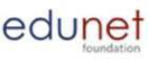

Edunet Foundation
AICTEInternshipOffer Letter
Dear Mr. /Ms. ADITYA SINGH
STU ID: STU69f102f6848f21777402614 | Internship ID: INTERNSHIP_17830691666a4779eecfe8a | Date: 10thAugust 2026
We would like to congratulate you on being selected for an internship brought to you by Edunet Foundation, leveraging
VOIS and Vodafone Idea Foundation’s - VOIS for Tech Program on DATA ANALYTICS. As an intern, you will learn and demonstrate
skills that will enhance your employability and your confidence in the subject area.
VOIS for Tech is an e-learning platform that helps technical students gain the foundational skills necessary to pick up market relevant
skills while earning credentials and receiving guidance for industry experts at no cost.
We are pleased to offer you Edunet Foundation internship for a period of 4 weeks beginning from 10thAug 2026 to 10thSept 2026.
During this internship, you will work independently on a project and be assigned a mentor who will guide you to identify a solution to
the problem and develop it into a project. The internship will be providing the following benefits:
• Access to VOIS for Tech e-Learning Platform with curated courses on technical skills
• Opportunity to accelerate your learning in project-based, collaborative environments
• Learners can experience masterclasses led by Subject Matter Experts
• Showcase your skills by solving real-world challenges
• Certification from AICTE and Edunet Foundation to enhance your value to future employers
Timeline and project:
The structure and timeline of the internship is as follows:
Week | Internship Plan | Date of the session
Week 0 | Orientation, LMS Registration and Internship schedule | 10thAug 2026
Week 1 | • Introduction to Data Analytics: key concepts, tools & techniques,  Overview of AI & LLMs  • Hands-on: HR data analysis using Python & Demo of certificate  course on VOIS LMS | 13thAug 2026
Week 2 | • Hands-on: Agriculture data analysis  • Dataset analysis & report preparation using LLM assistance  • Certificate Course: Data Visualization & Hands-on | 20thAug 2026
Week 3 | • Hands-on: Business & Operations data analysis  • Dataset analysis & report preparation using LLM assistance & DIY  Project Discussion | 27thAug 2026
Week 4 | • Project completion and submission  • Project Submission Discussion  • Final Q&A / Doubt-Clearing Session | 3rdSept 2026
Week 5 | AMA Session/QnA (Ask me anything) | 10thSept 2026
Criteria for certification:
• Participation in weekly sessions with mentors is mandatory
• Completion of tasks/milestones on a weekly basis
• Completion of courses on VOIS for Tech LMS
• Submission of projects documents is required
Stipend:
There will be NO stipend for this internship. If you agree to the above terms of the offer, please indicate acceptance of the offer
letter and below undertaking to the undersigned.
Sincerely,
Nagesh Singh
Chairman – Edunet Foundation

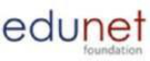


Undertaking Agreement
I, ADITYA SINGH, from COLLEGE OF MANAGEMENT STUDIES, IILM ACADEMY O who is undergoing an
internship at Edunet Foundation, do hereby undertake on 10THAugust 2026, the following:
1. I will be present at the weekly sessions conducted virtually, as organized by the mentor and team, to undertake the courses
assigned to me for the duration of the internship. I will communicate to the mentor and team should there be any reason or
inability to be present.
2. I will communicate regularly with the said mentor on the courses' progress.
3. I declare that I will ensure the timely submission of the project and will deliver a presentation within the stipulated time to
complete the internship and earn a certificate.
4. I will adhere to and maintain the decorum of weekly sessions conducted virtually and will not be involved in any disciplinary
practice during the same and abide by ethical standards followed by Edunet Foundation under VOIS for Tech Program.
5. I declare that my internship with Edunet Foundation shall be terminated at any stage on the grounds of:
o Absenteeism from masterclasses and mentor-led sessions
o Not in touch with mentor
o Mentor identifies that there is no progress on project
o Not reachable by Edunet Foundation
6. I further declare that my internship shall be terminated forthwith at any stage, misbehavior, inciting hatred, indiscipline,
habitual insubordination etc. or on grounds of misconduct etc. as came to the notice of Edunet Foundation.
Sincerely,
Sign Here
Date: 10thAugust 2026
Name of Student: ADITYA SINGH
Student ID: STU69f102f6848f21777402614
Internship ID: INTERNSHIP_17830691666a4779eecfe8a

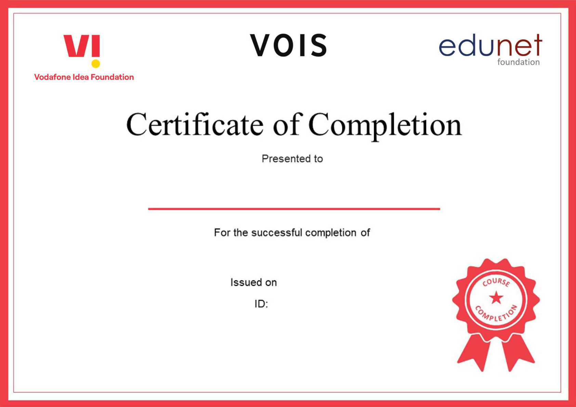




Aditya Singh
Getting Started with Python Environment Installations
August 12, 2026
VFLMS26_160951








Aditya Singh
Getting Started with Python Environment Installations
August 12, 2026
VFLMS26_160951








Aditya Singh
Getting Started with Python Environment Installations
August 12, 2026
VFLMS26_160951

